Splunk Lab Demo

Viewing source types:
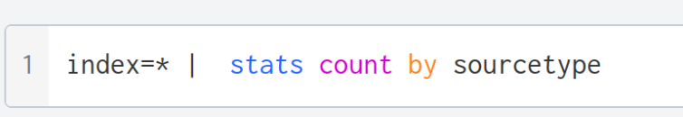
Figure 1 Able to view the sourcetype by which is producing the most amount of data
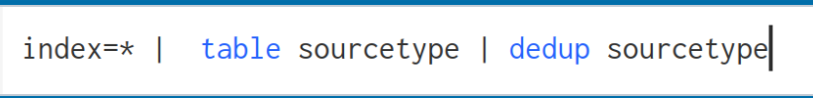
Figure 2 Another way to view source types

Analysing source types:
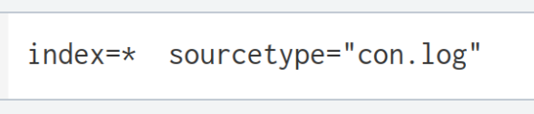
Figure 3 Searching for a specific source type

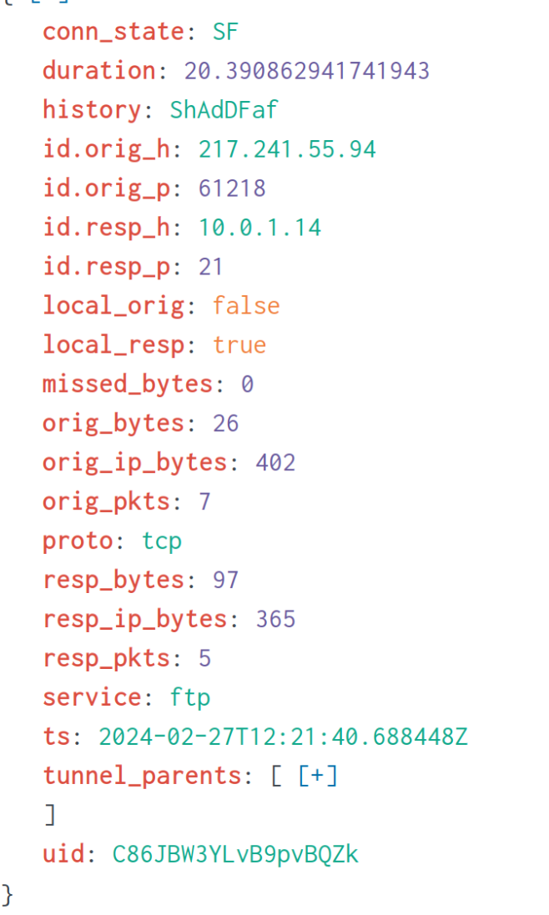
Figure 5 shows all the key and values pairs in one con.log event

Figure 4 Able to table certain variables in a sourcetype

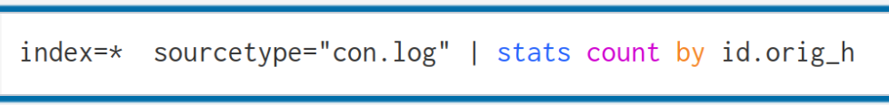
Figure 5 shows the a stat count by src ip
Figure 6 shows the output of a stats count by

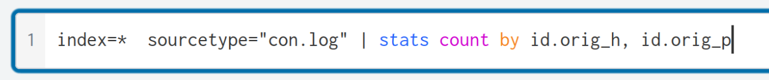
Figure 7 shows a stats count by multiple variables
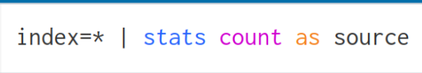
Figure 8 shows we can make a stats count as which gives us a number of events with a certains filter. Good for making a alerts on!

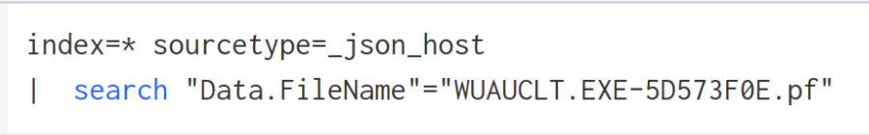
Figure 9 shows using the search fiter in splunk to look for specific strings in splunk

Figure 10 shows using a search statement and using AND statement and !=

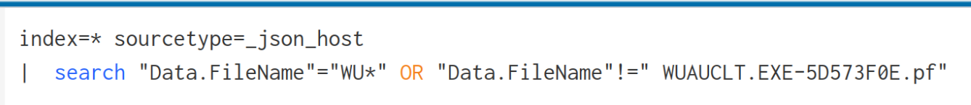
Figure 11 shows using an OR statement
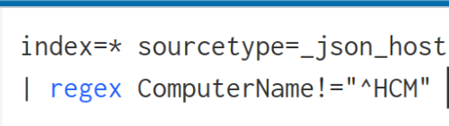
Figure 12 You can regex certain fields to better your search this query is saying don’t show me any ComputerName that starts with HCM
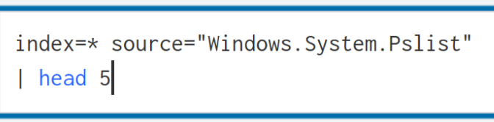
Figure 13 You can use the head command to view the top 5 events in a search
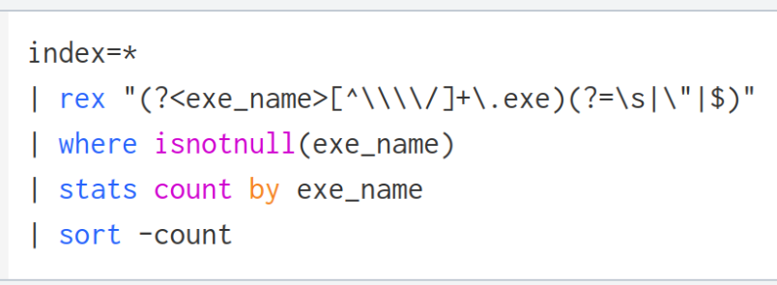
Figure 14 shows you can extract a field in splunk using regex (complicated use AI) stats -count shows the output
o some 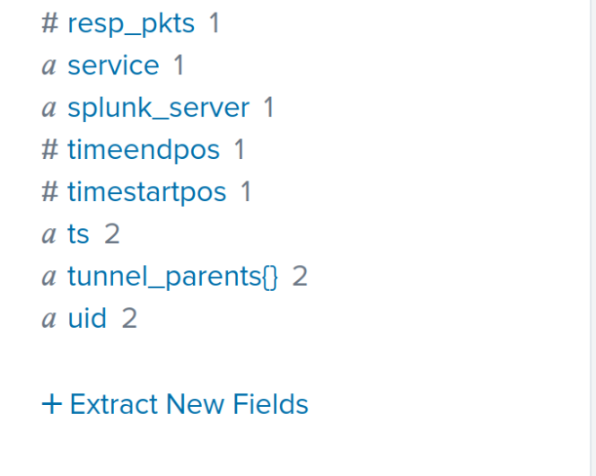

Baselining
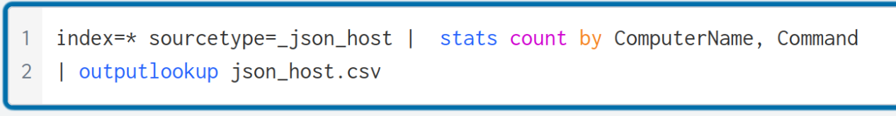
Figure 15 shows making a CSV file from your seach commands
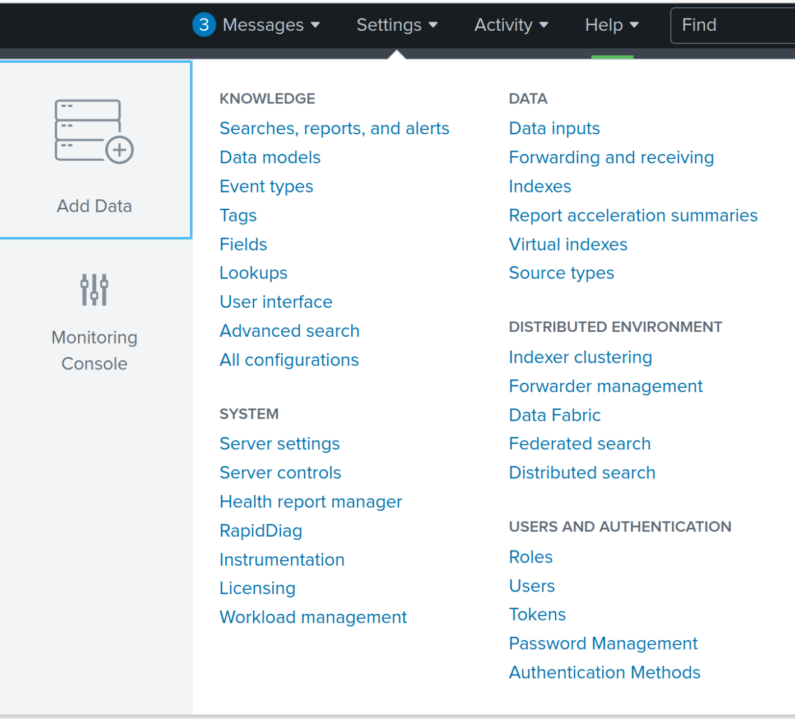
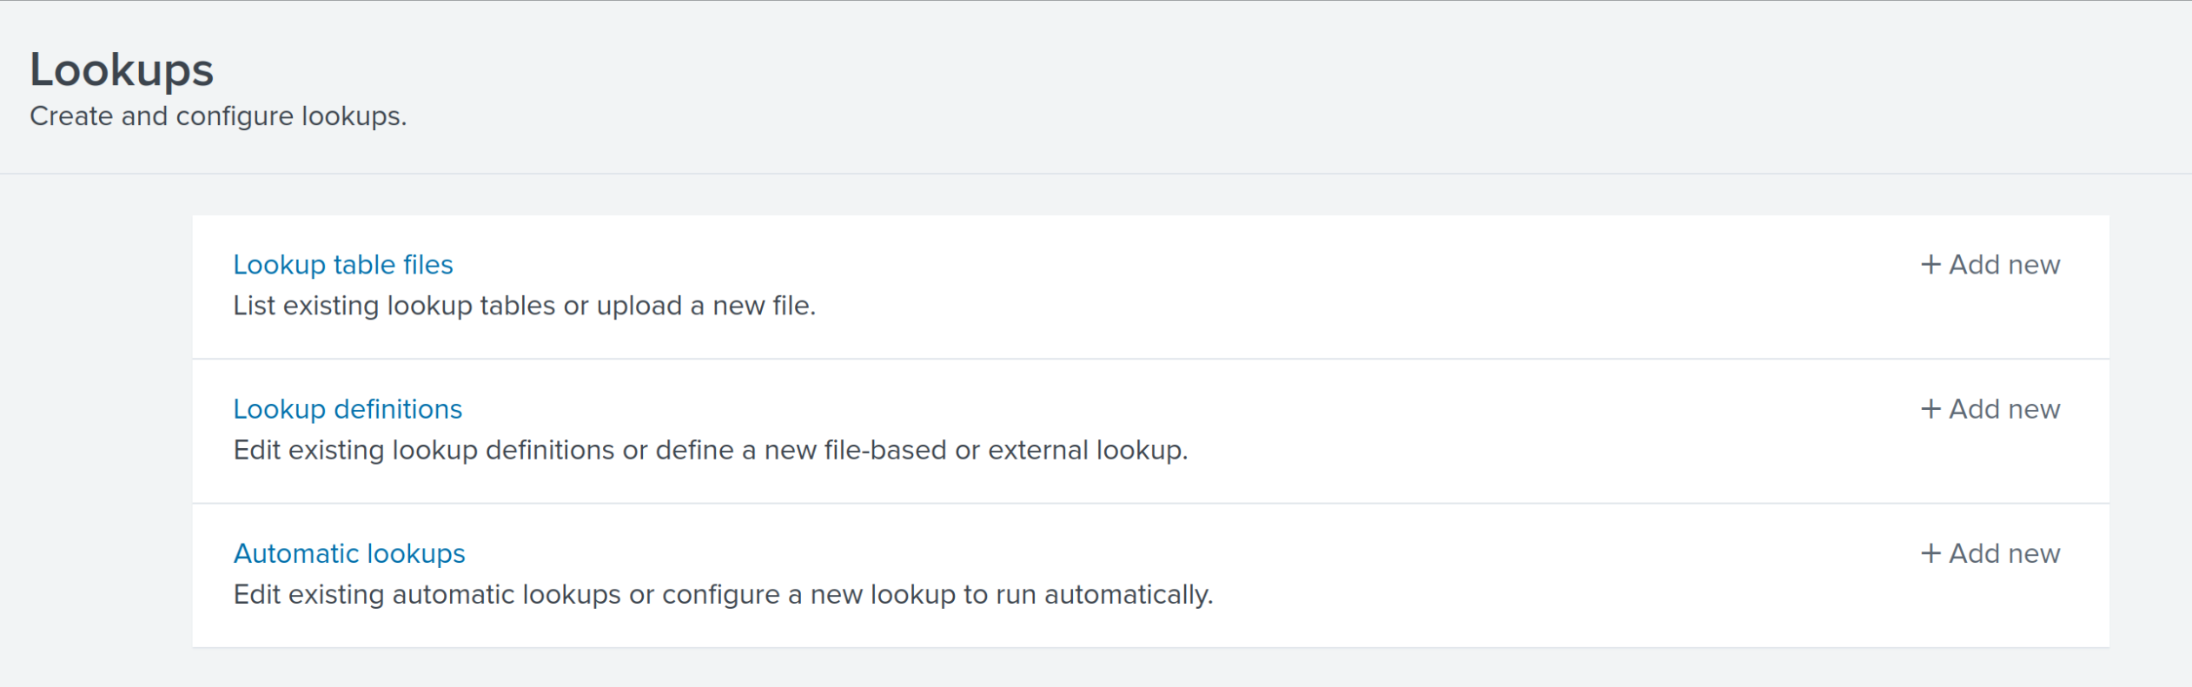
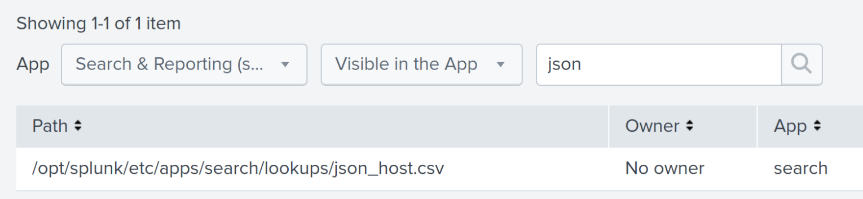
Figure 16 shows how to make check your CVS has been loaded into Splunk
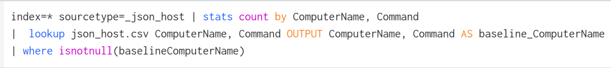
Figure 17 shows a comparison of any new unique events occurring with this source type

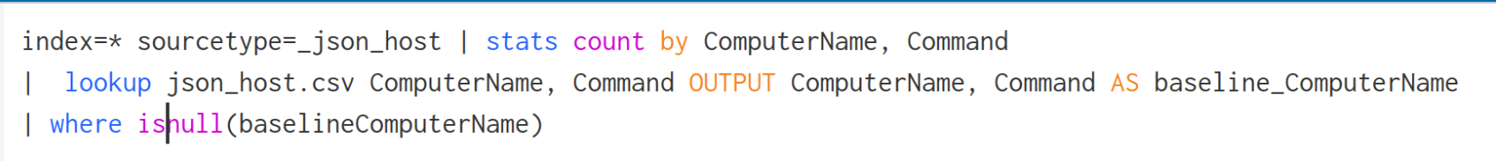
Figure 18 shows new events which have been previously baselined in the network (kind of useless but good to know)

Making a dashboard
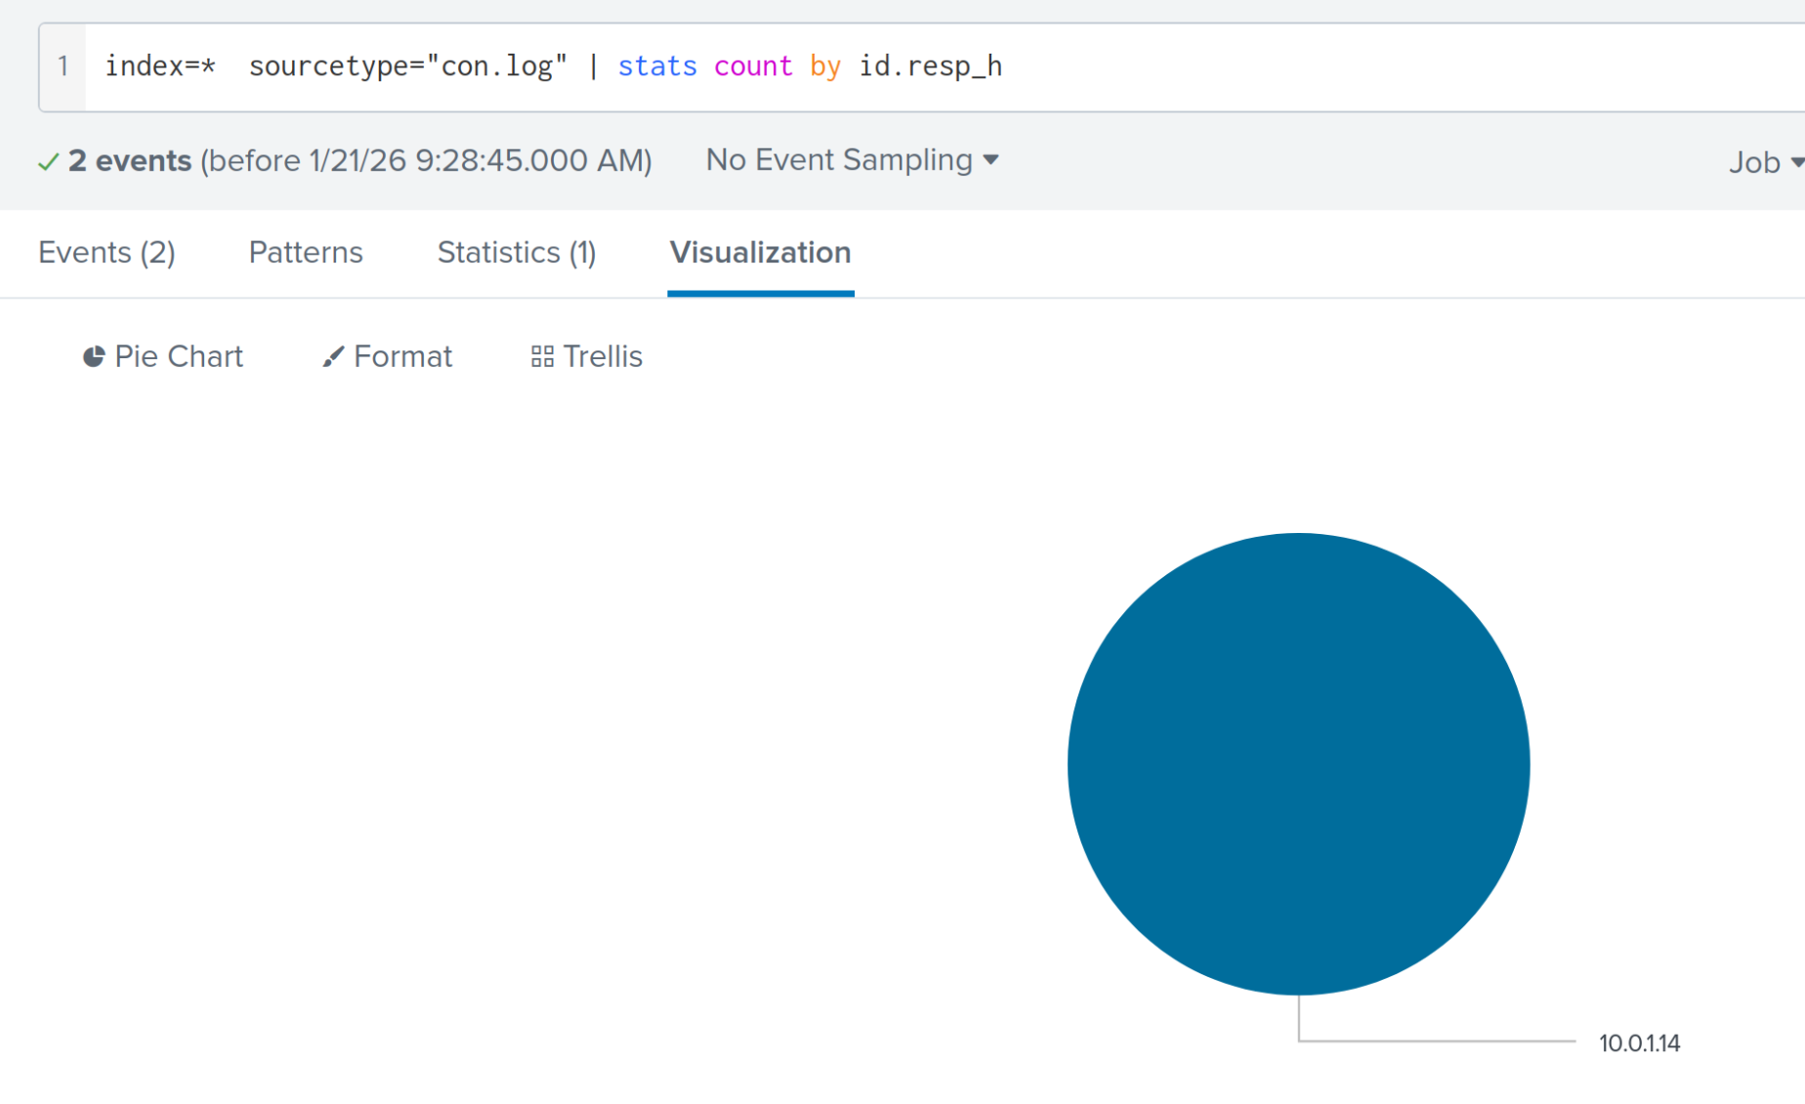
Figure 19 shows using the visualisation tab to find a data structure to better show the data
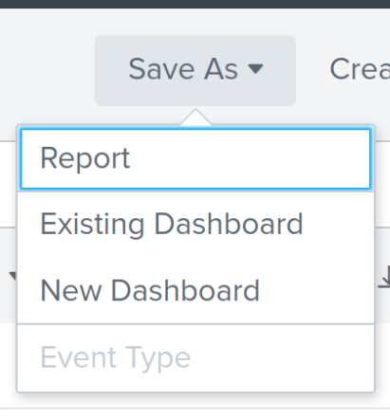
Figure 20 select a new dashboard
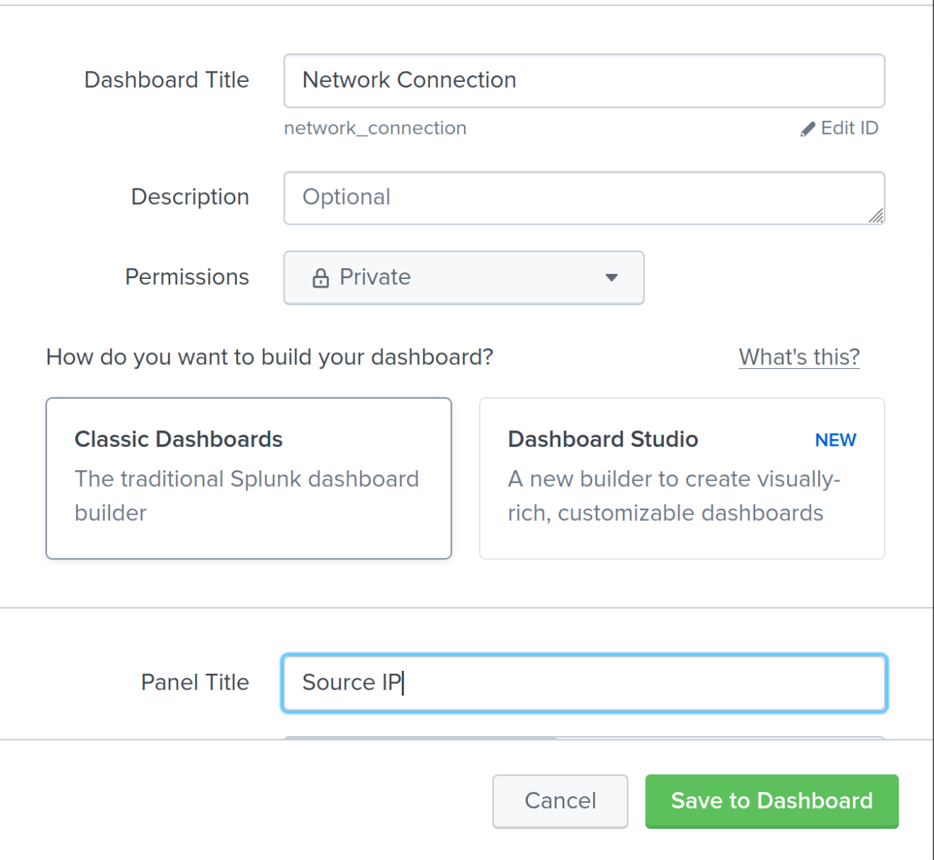
Figure 21 shows making a new dashboard
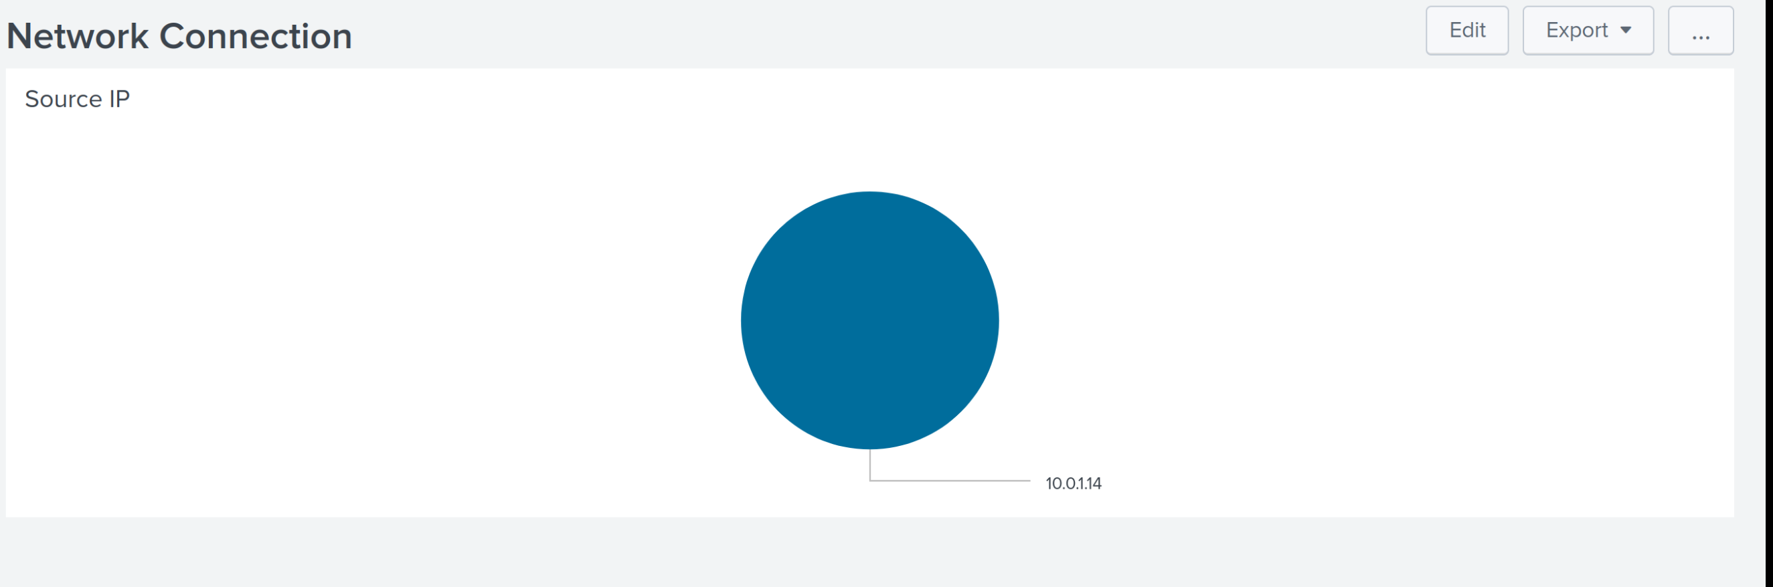
Figure 22 Dashboard created
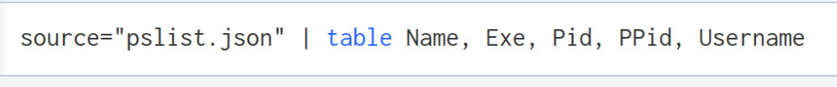
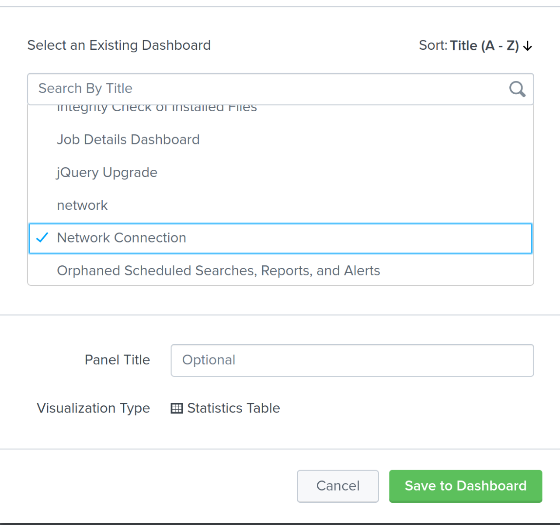
Figure 23 Making a table search and adding it to my existing dashboard

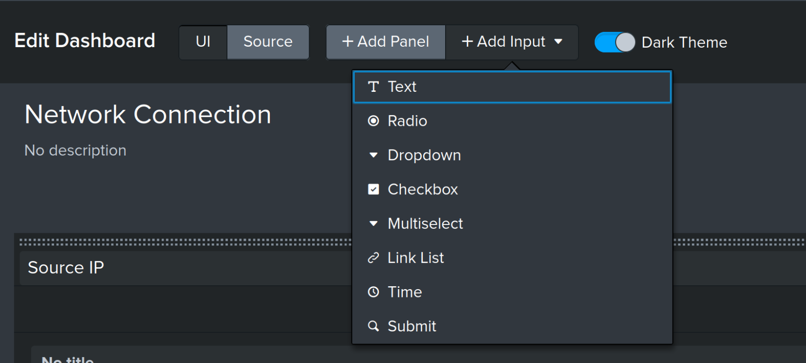
Figure 24 select text tab
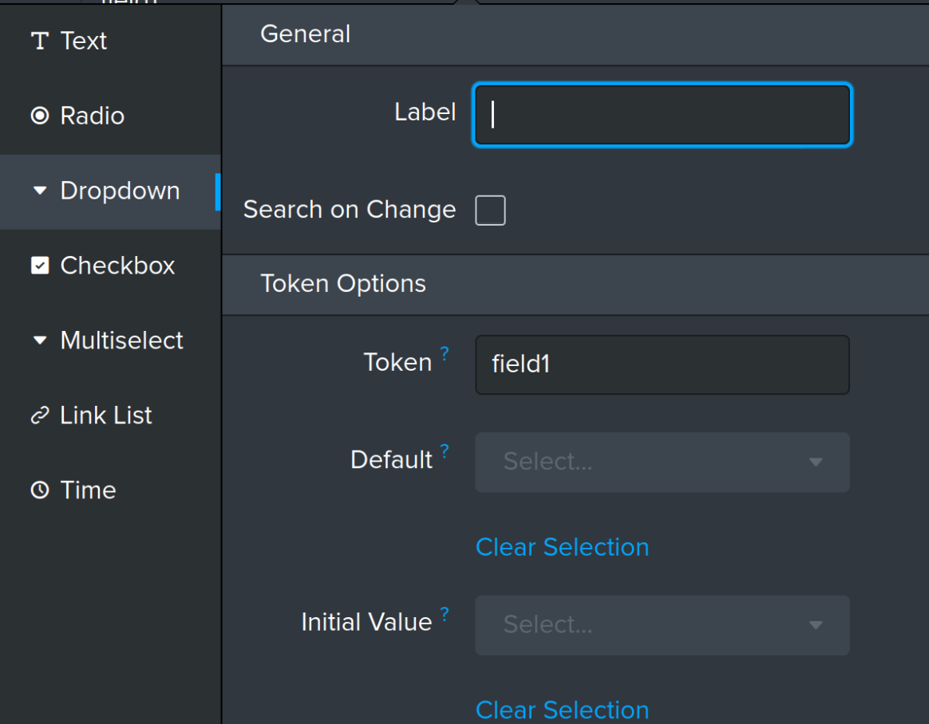
Figure 25 Select Drop down
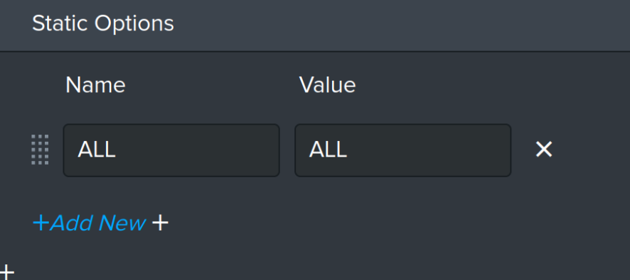
Figure 26 Go to static Options and select ALL, ALL
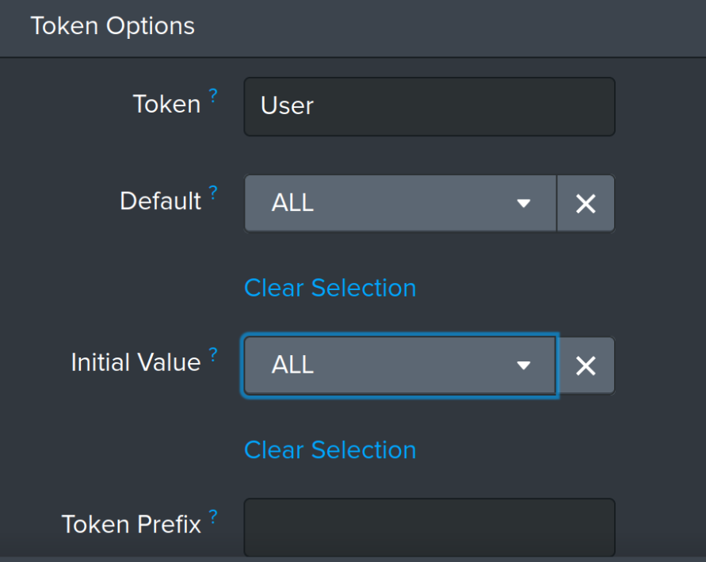
Figure 27 shows selecting ALL, ALL in token options
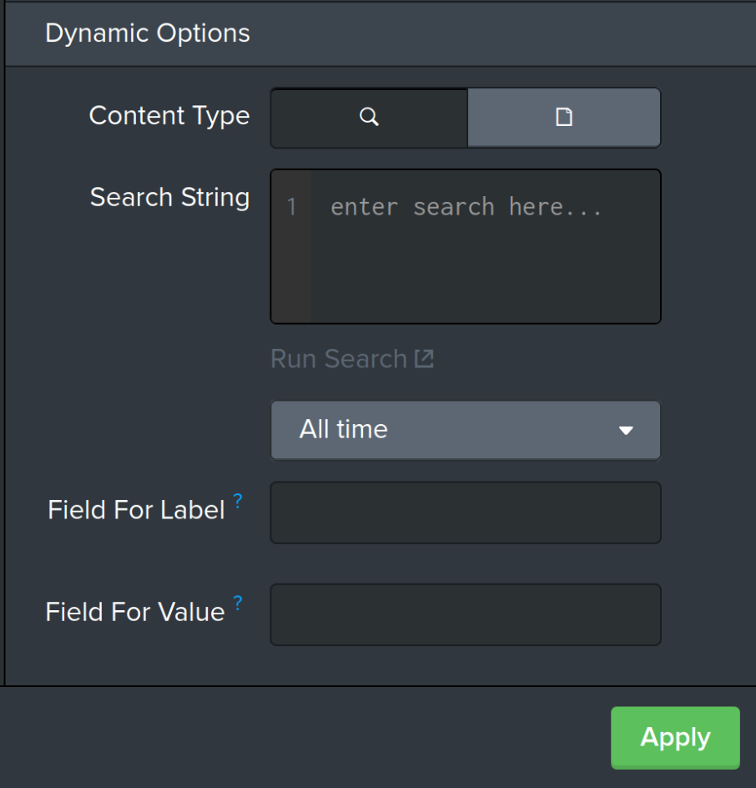
Figure 28 Click apply to save your current values
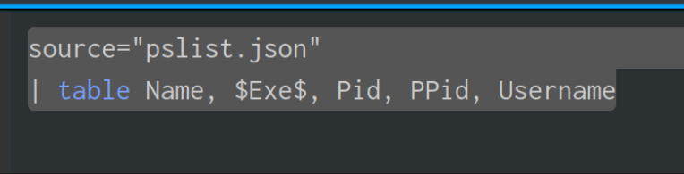
Figure 29 Go to your table which you are trying to make a filter on and copy and paste the search query back into your Text filter
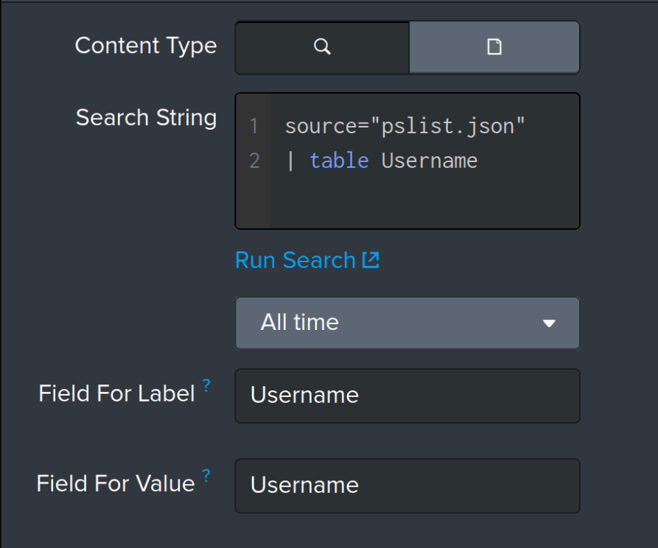
Figure 30 Paste your search query in the search string and delete all the fields which aren’t related to what you want to search select Apply afterwards
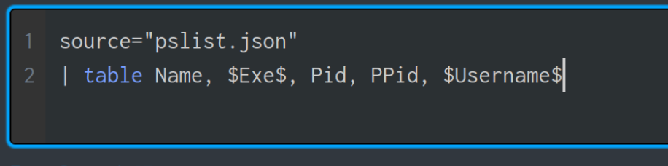
Figure 31 shows putting a $<field>$ in the original graph around the value you are trying to extract

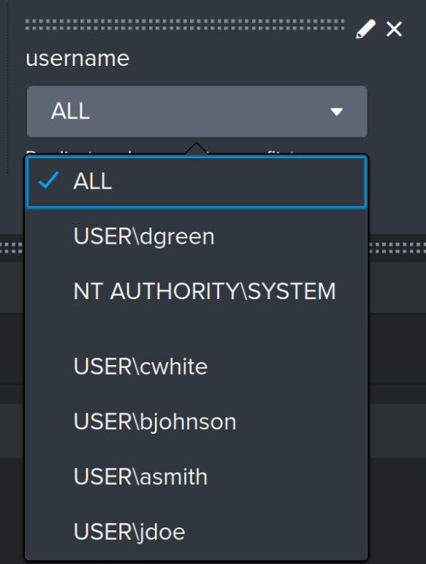
Figure 32 shows the dropdown menu giving all the users from the events

Another Option for string searching your dashboard
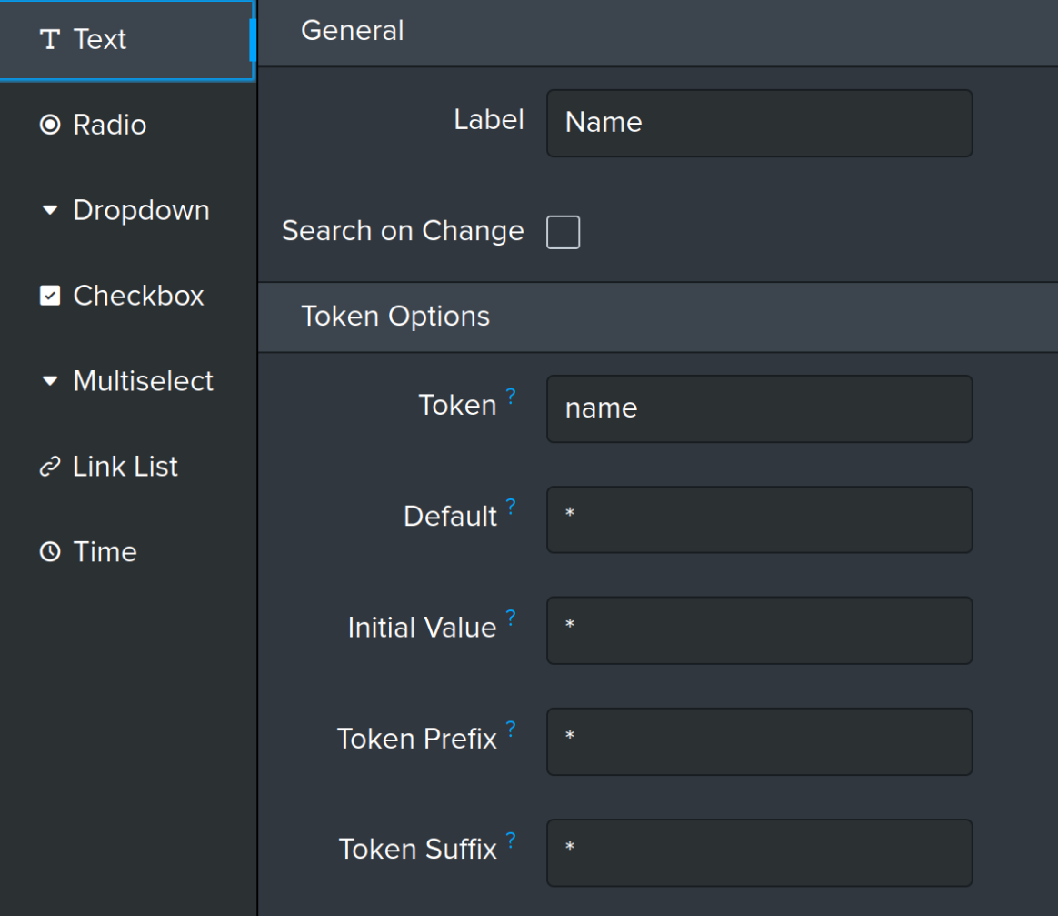
Figure 33 Shows you going to the text table and making a variable called Name and a token called name
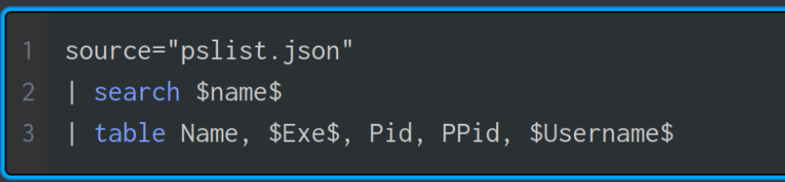
Figure 34 shows in your original graph adding a search field with the $name$ token allows for the search to be complete
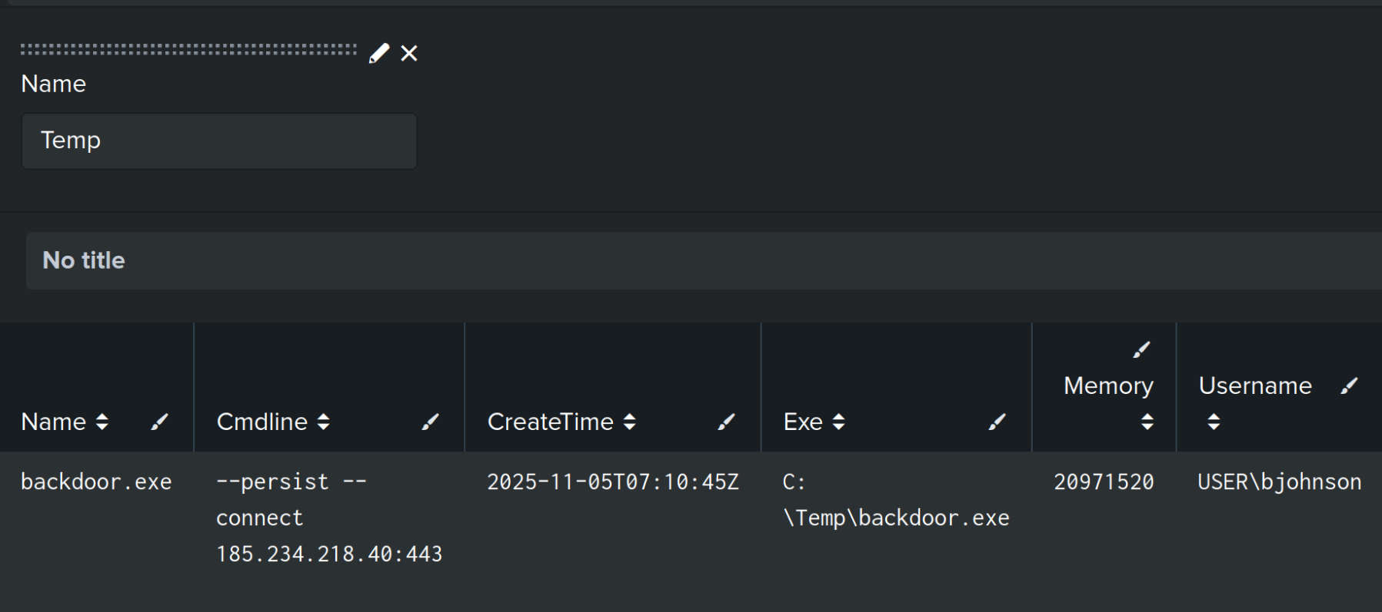
Figure 35 shows the search filter working

